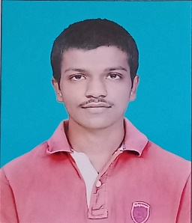**RESUME**

**OM MILIND BHAGWAT**

+91 86698 21909

Add: Flat no. 15, Samruddhi Palace, Swami Vivekanand

Nagar, Makhamalabad, Nashik 422003

Email id: [ombhagwat41@gmail.com](mailto:ombhagwat41@gmail.com)

**OBJECTIVE**

To work with an organization where can learn skills and increase my abilities for the organizational goals as well as myself.

**EDUCATIONAL** **QUALIFICATION**

* Pursuing BSC (C.S) 3rd year from Gokhale Education Society (R.Y.K College) Pune University.
* Passed out 12th HSC bord in 2021.

Percentage:79.67

* Passed out 10th SSC bord in 2019.

Percentage: 79.20

**TECHNICAL** **SKILLS**

* Basic knowledge of computer.

**WORK &EXPERIENCE**

Fresher.

**STRENGTH & HOBBIES**

* Creativity.
* Open minded.
* Reading.
* Running.